Software Requirements Specification
for
Special Needs Conveyance(SNC)
Version 1.0 approved
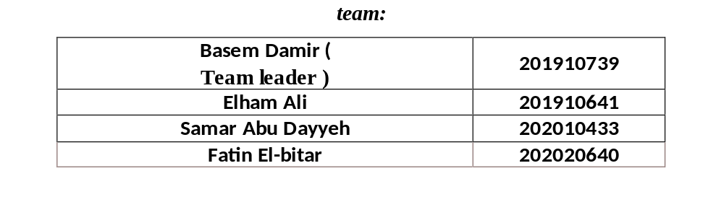

Introduction

This requirements specification document is intended to clarify the main requirements and specifications for a mobility disability application. The application aims to facilitate the lives of individuals with special needs by providing an easy-to-use interface that enables them to access services and content comfortably.

2. Project description:

The app is a mobile platform that aims to provide services and support to individuals with mobility impairments. The application allows users to request services such as delivery, the ability to search, follow up on health status, and communicate with the relevant authorities.

3. User Requirements:

Users must be able to download the application on their mobile phones.

The application must be compatible with Android and iOS platforms.

The application should be easy to use with a simple and clear user interface.

4. System requirements:

The application must be able to load and display content quickly.

Secure login and authentication must be supported.

The app should be easily updated to fix bugs and add more features.

5. Job Requirements:

Users must be able to register personal accounts and store their information.

The application should allow users to order delivery services from different locations.

Users must be able to search for specific content by their voice.

Users shall be able to update their health status and track their progress in fitness programmes.

6. Security requirements:

User information must be stored securely and encrypted.

There must be a strong authentication system to ensure access to personal information.

7. Performance requirements:

The application must be fast to load and respond to user actions.

The application must support a large number of users at the same time.

8. Compatibility Requirements:

The app should be compatible with different screen sizes and mobile devices.

The application must be compatible with the latest OS versions of each platform.

9. Support and Maintenance Requirements:

Technical support should be provided to users in case of problems or inquiries.

There should be clear procedures for updating and maintaining the application on a regular basis.

10. Interface Requirements:

The application interface should be simple and easy to use, with a design that takes into account the needs and capabilities of users with special needs.

The interface should allow easy navigation between the various pages and functions.

11. Language requirements:

The application must be available in an easy-to-understand and easy-to-use Arabic language.

12. Communication Requirements:

The application must provide means of communication with the support team, whether it is via email or live chat.

13. Storage requirements:

Users' information and sensitive data must be stored securely, ensuring that privacy is protected and that no unauthorized access is made.

14. NOTICE REQUIREMENTS:

The application must provide the ability to send notifications to users regarding the status of orders or any important events.

15. Requirements for improvement:

There should be possibility to improve the app based on users' feed and suggestions.

16. Test Requirements:

The application must be thoroughly tested before it is released to the public, with any bugs discovered corrected.

17. RELEASE AND DISTRIBUTION REQUIREMENTS:

Strong and secure hosting servers must be equipped to run and deploy the application.

There should be a plan to announce the launch of the application and attract users.

18. Intellectual Property Requirements:

The development team must abide by intellectual property rights laws and not violate the rights of others.

19. Training and Support Requirements:

A detailed usage guide shall be provided to users.

Users should be offered electronic training courses or workshops to learn how to use the application effectively.

